MSCD 600 Database Architecture

Lab 1

The purpose of this lab is to gain some basic SQL*Plus skills such as running commands, creating files that contain SQL commands, spooling output to a file, and running basic SQL queries.

To show that you have successfully executed each step, you can either cut and paste the output on your screen and paste it into this Word document, or you can capture screen shots and paste them into this document. For information on how you will be evaluated refer to the Labs Rubric at the end of this document below.

Login to the database with your username before starting. To login, refer to the Course Resources\Student_Instructions_Static_Database_Xen_Servers.pdf which is also located in the Course Resources folder for easy access throughout this course.

**----------------------------------------------------------------**

**Step 1:** Show the currently connected user.

SQL> show user;

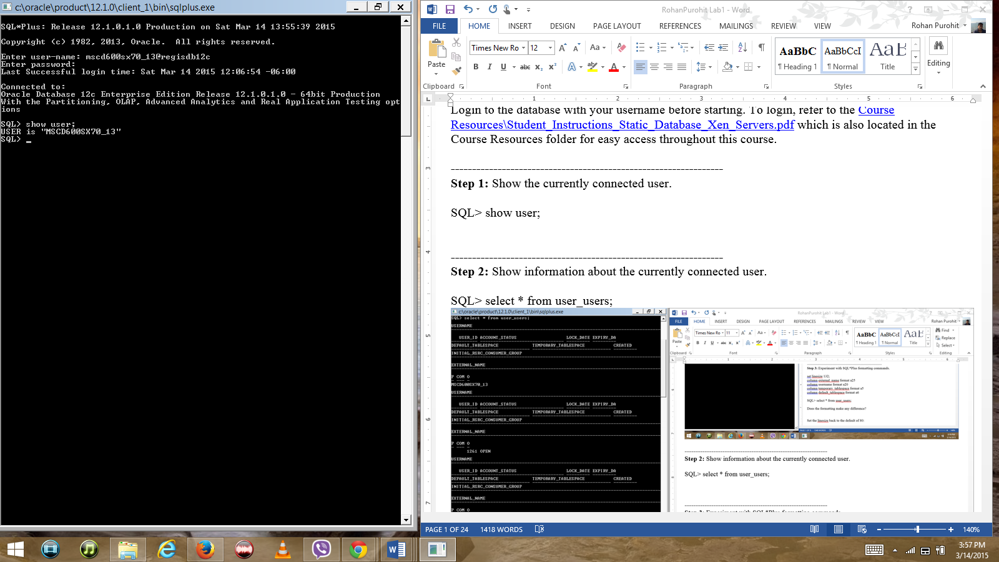

**----------------------------------------------------------------**

**Step 2:** Show information about the currently connected user.

SQL> select * from user_users;

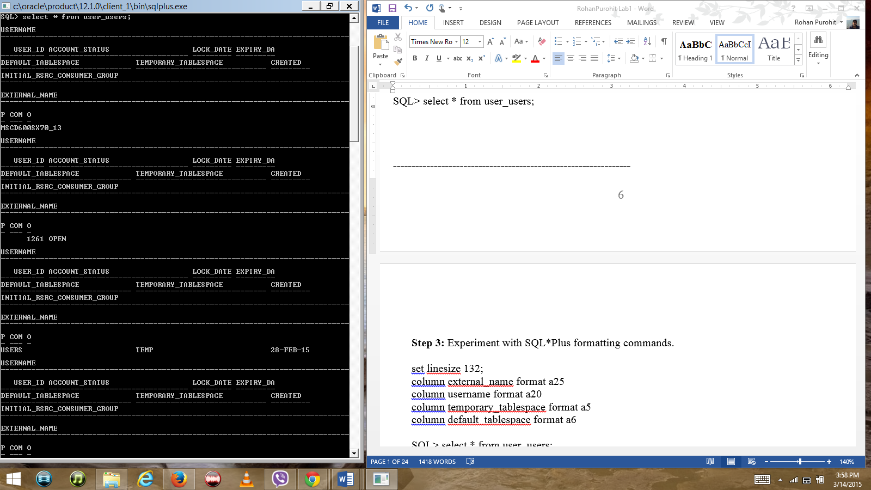

**----------------------------------------------------------------**

**Step 3:** Experiment with SQL*Plus formatting commands.

set linesize 132;

column external_name format a25

column username format a20

column temporary_tablespace format a5

column default_tablespace format a6

SQL> select * from user_users;

Does the formatting make any difference?

Yes.

Set the linesize back to the default of 80:

SQL> set lines 80;

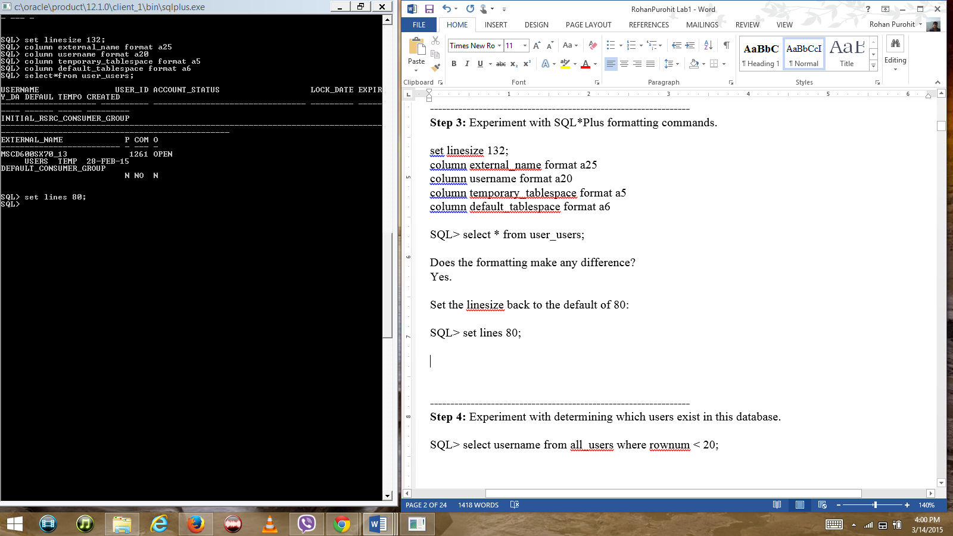

**----------------------------------------------------------------**

**Step 4:** Experiment with determining which users exist in this database.

SQL> select username from all_users where rownum < 20;

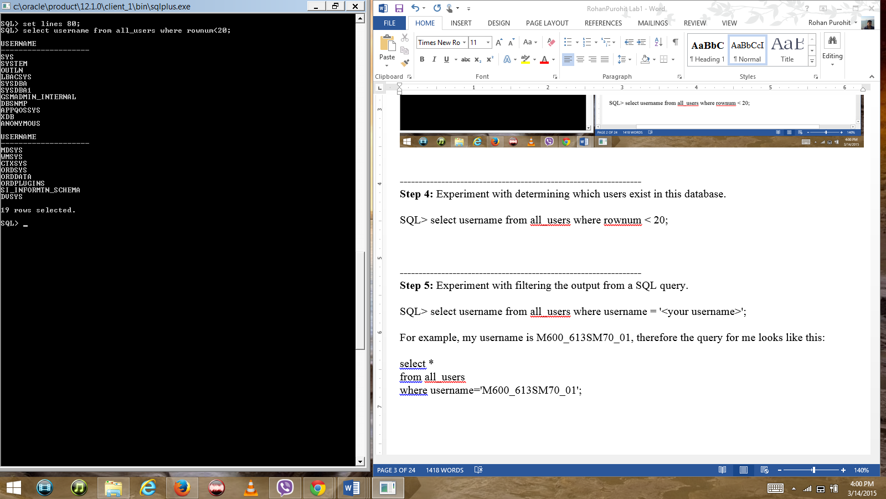

**----------------------------------------------------------------**

**Step 5:** Experiment with filtering the output from a SQL query.

SQL> select username from all_users where username = '<your username>';

For example, my username is M600_613SM70_01, therefore the query for me looks like this:

select *

from all_users

where username='M600_613SM70_01';

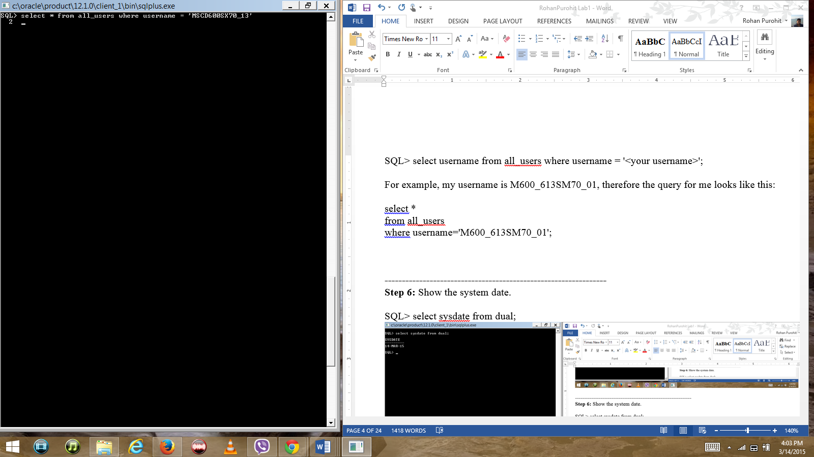

**----------------------------------------------------------------**

**Step 6:** Show the system date.

SQL> select sysdate from dual;

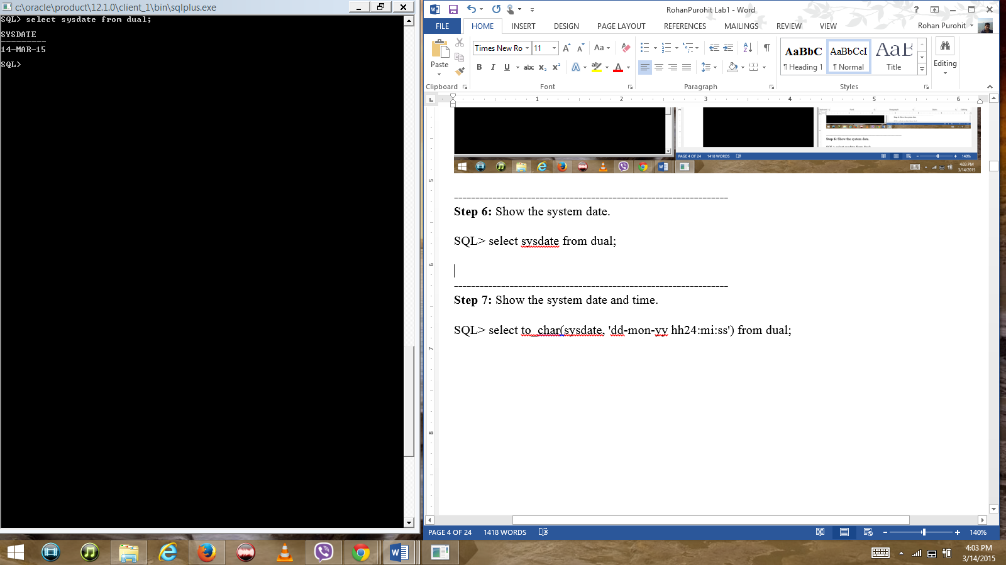

**----------------------------------------------------------------**

**Step 7:** Show the system date and time.

SQL> select to_char(sysdate, 'dd-mon-yy hh24:mi:ss') from dual;

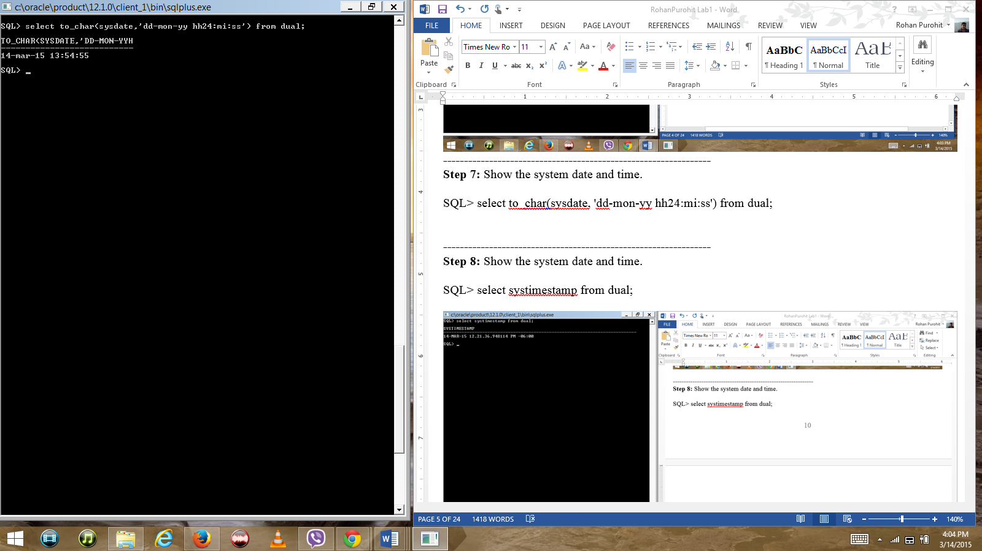

**----------------------------------------------------------------**

**Step 8:** Show the system date and time.

SQL> select systimestamp from dual;

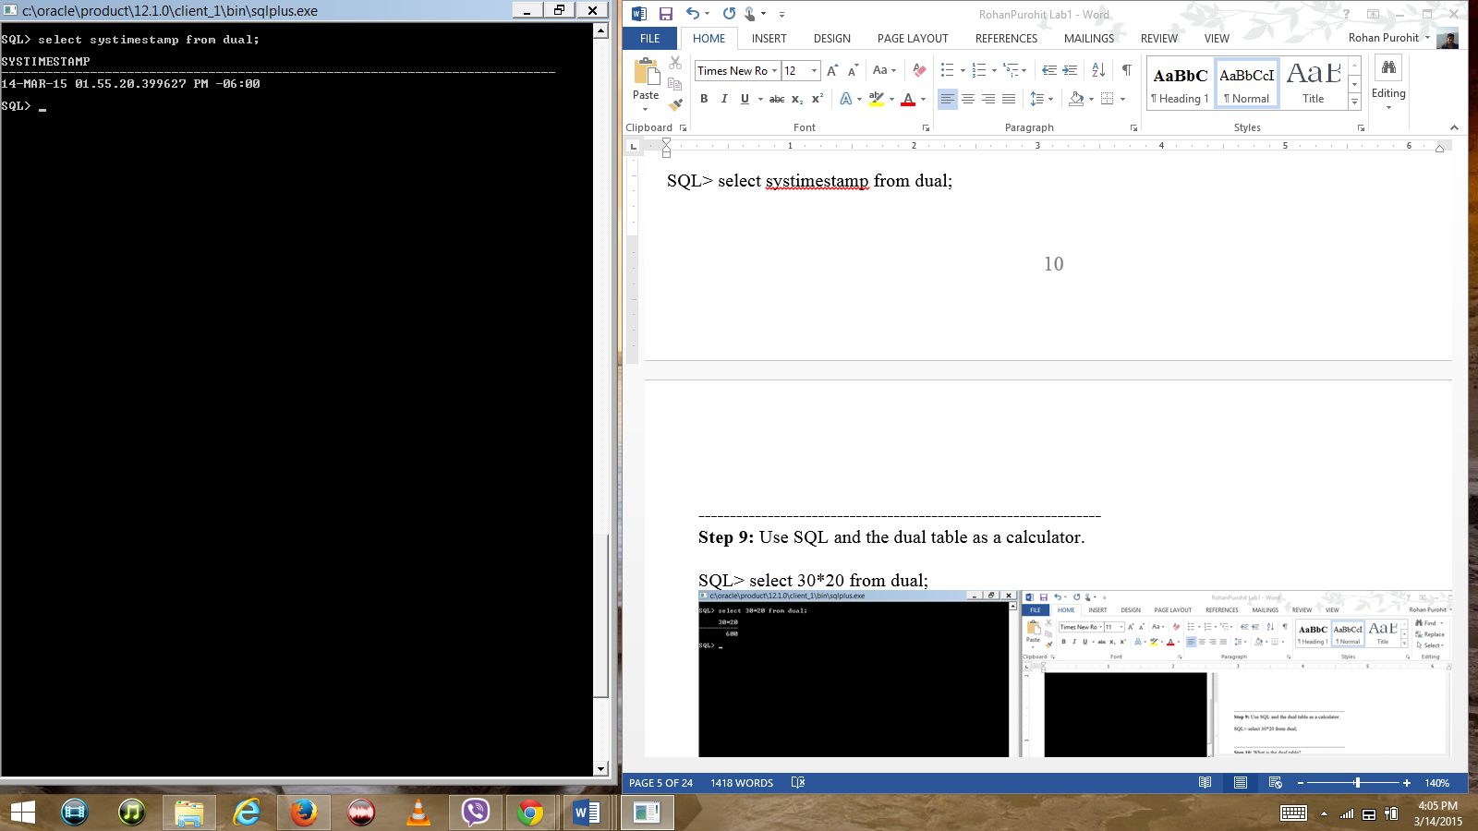

**----------------------------------------------------------------**

**Step 9:** Use SQL and the dual table as a calculator.

SQL> select 30*20 from dual;

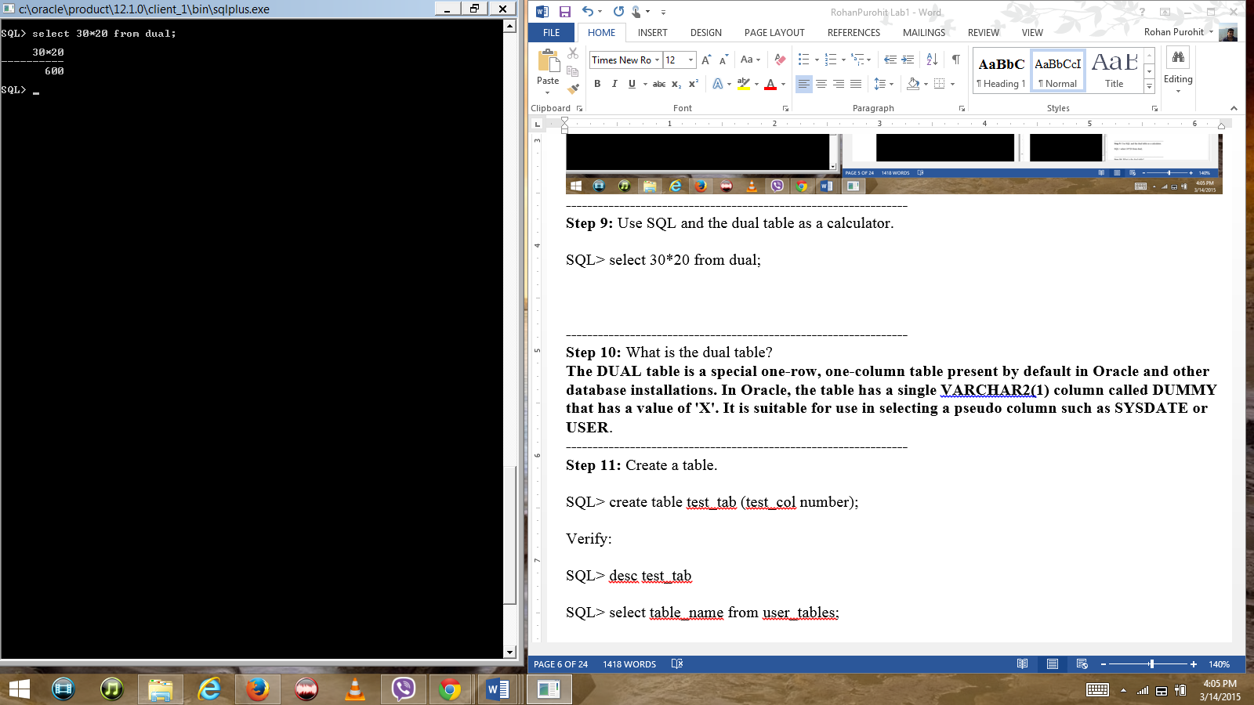

**----------------------------------------------------------------**

**Step 10:** What is the dual table?

**The DUAL table is a special one-row, one-column table present by default in Oracle and other database installations. In Oracle, the table has a single VARCHAR2(1) column called DUMMY that has a value of 'X'. It is suitable for use in selecting a pseudo column such as SYSDATE or USER**.

**----------------------------------------------------------------**

**Step 11:** Create a table.

SQL> create table test_tab (test_col number);

Verify:

SQL> desc test_tab

SQL> select table_name from user_tables;

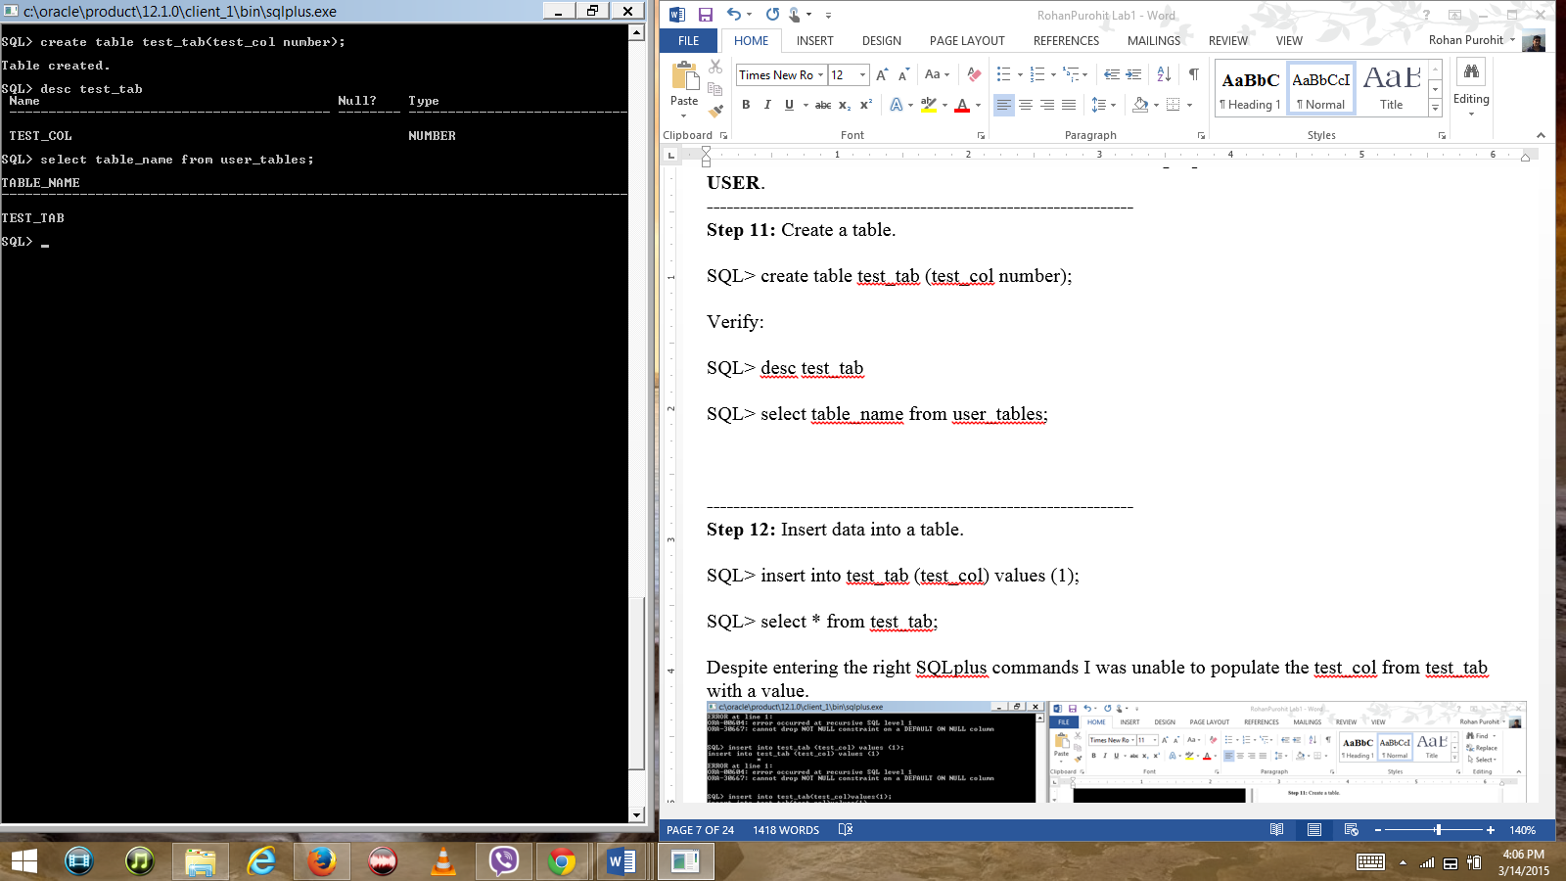

**----------------------------------------------------------------**

**Step 12:** Insert data into a table.

SQL> insert into test_tab (test_col) values (1);

SQL> select * from test_tab;

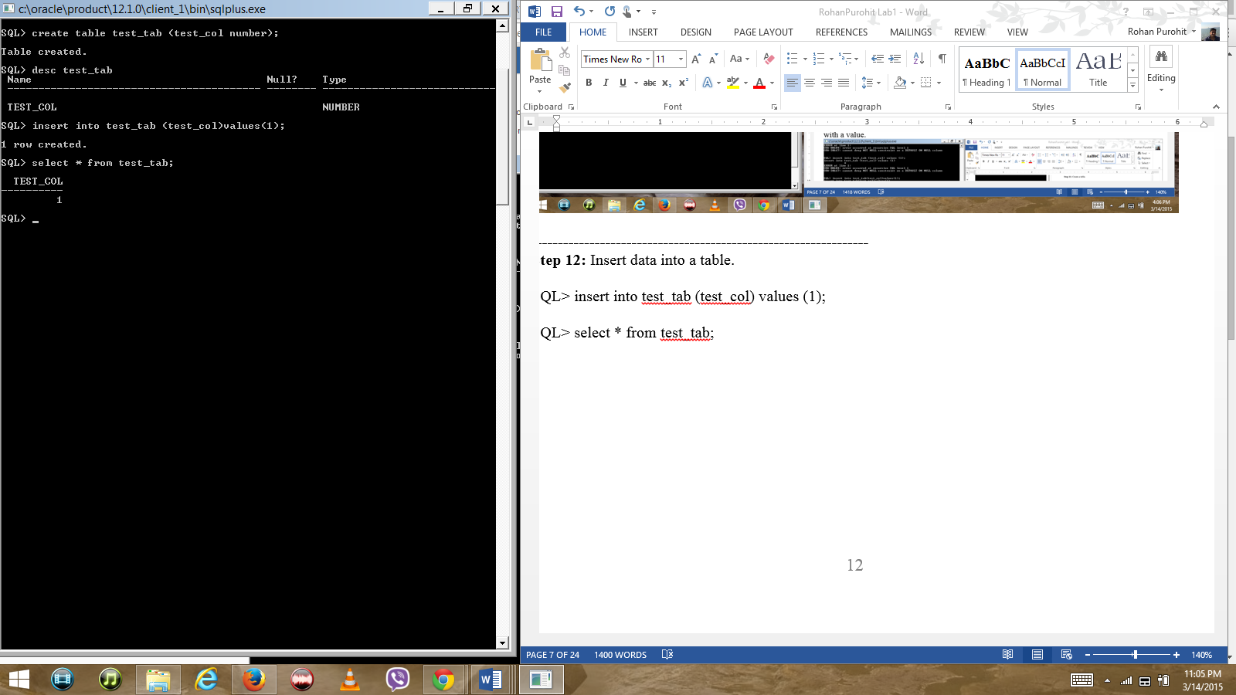

**----------------------------------------------------------------**

**Step 13:** Experiment with selectively selecting from a table.

SQL> select test_col from test_tab where test_col = 0;

SQL> select test_col from test_tab where test = 1;

SQL> select test_col from test_tab where test_col = 1;

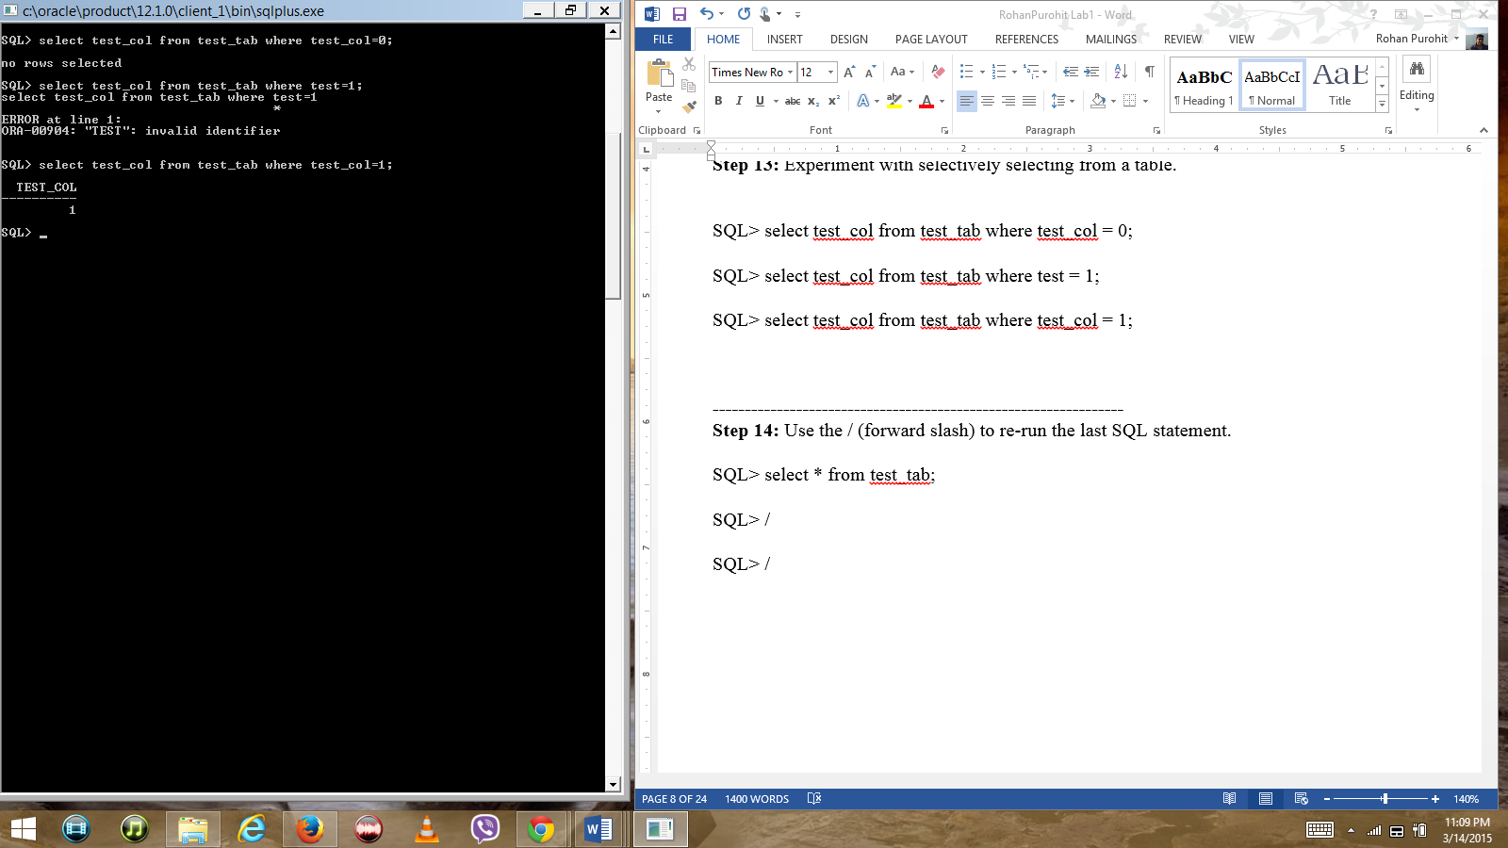

**----------------------------------------------------------------**

**Step 14:** Use the / (forward slash) to re-run the last SQL statement.

SQL> select * from test_tab;

SQL> /

SQL> /

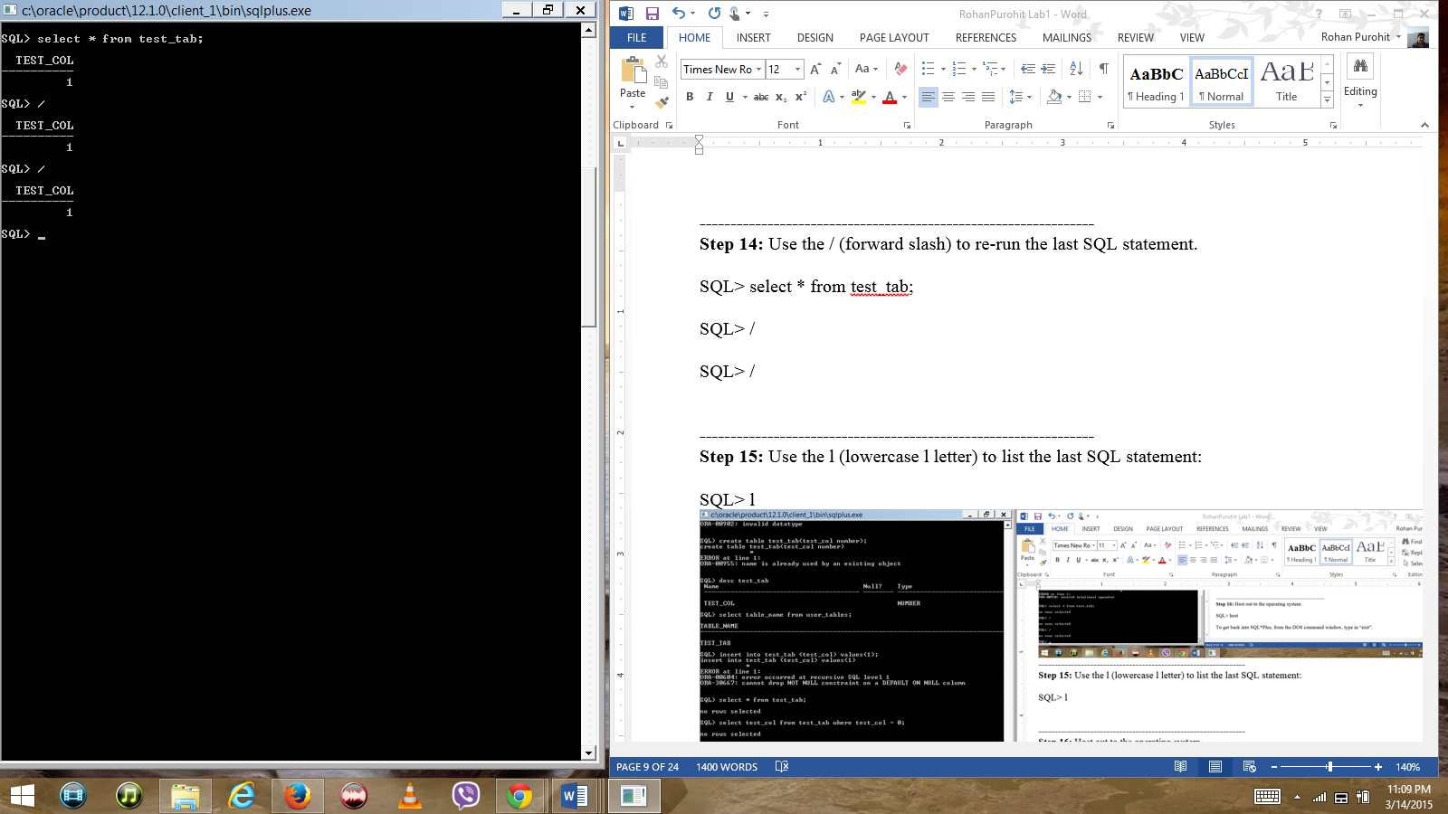

**----------------------------------------------------------------**

**Step 15:** Use the l (lowercase l letter) to list the last SQL statement:

SQL> l

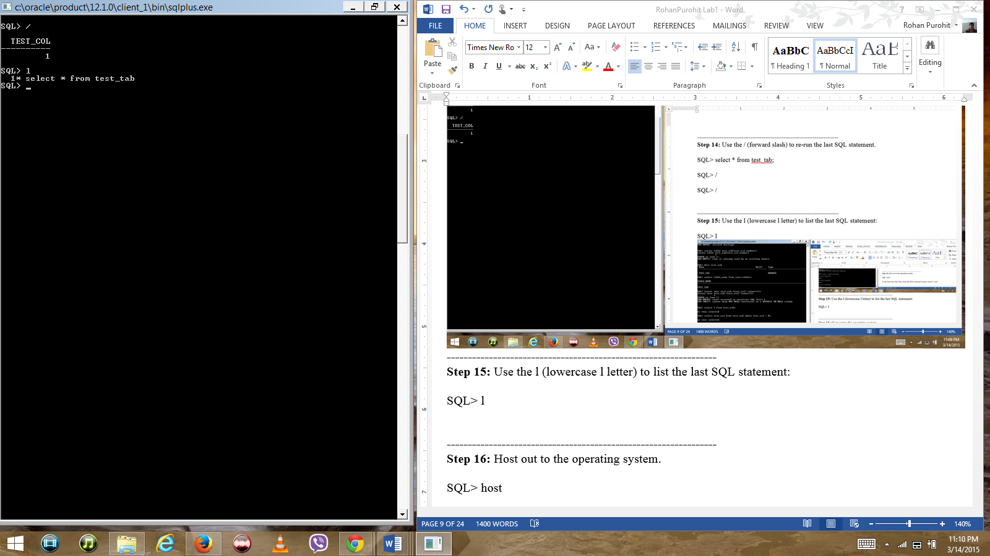

**----------------------------------------------------------------**

**Step 16:** Host out to the operating system.

SQL> host

To get back into SQL*Plus, from the DOS command window, type in “exit”.

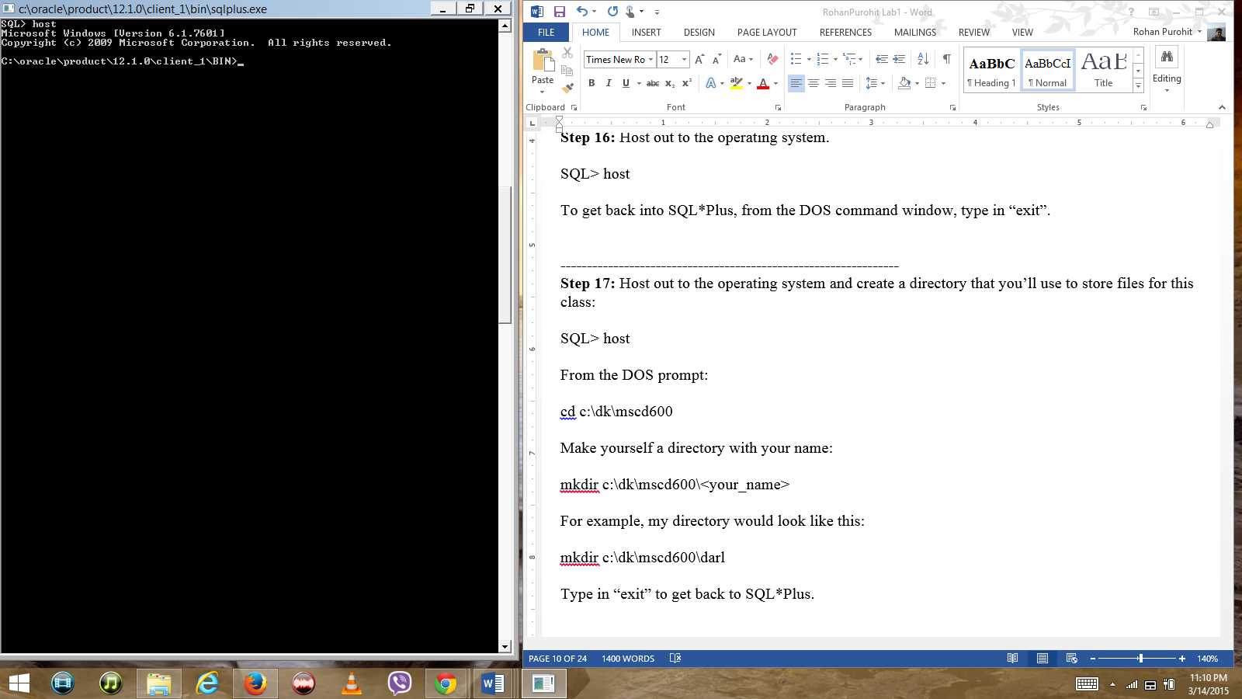

**----------------------------------------------------------------**

**Step 17:** Host out to the operating system and create a directory that you’ll use to store files for this class:

SQL> host

From the DOS prompt:

cd c:\dk\mscd600

Make yourself a directory with your name:

mkdir c:\dk\mscd600\<your_name>

For example, my directory would look like this:

mkdir c:\dk\mscd600\darl

Type in “exit” to get back to SQL*Plus.

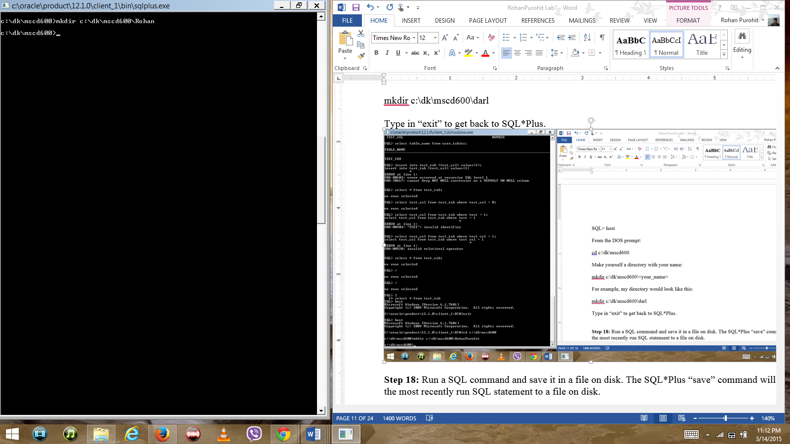

**Step 18:** Run a SQL command and save it in a file on disk. The SQL*Plus “save” command will save the most recently run SQL statement to a file on disk.

SQL> select * from test_tab;

Save that SQL command to a file on disk:

SQL> save c:\dk\mscd600\<your_name>\test_sql.sql

For example, to save a file to my directory on disk:

SQL> save c:\dk\mscd600\darl\test_sql.sql

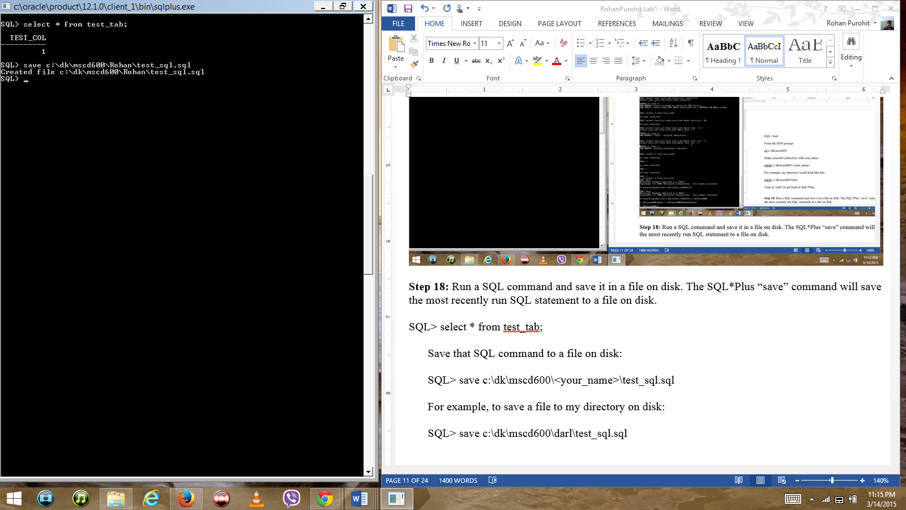

**----------------------------------------------------------------**

**Step 19:** Verify that the SQL file is on disk:

SQL> host;

cd c:\dk\mscd600\<your_name>

Run the DOS dir command:

dir

Do you see the file?

Yes, I see the file as test_sql.sql

Type “exit” to return to SQL*Plus.

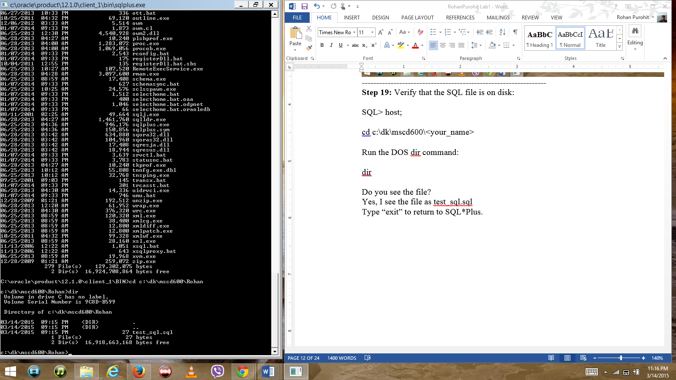

**----------------------------------------------------------------**

**Step 20:** Run a saved file. To execute SQL commands stored in a file, you need to run the file, you tell SQL*Plus to do this with the “@” command followed by the directory path and name of file.

SQL> @c:\dk\mscd600\<your_name>\test_sql.sql

SQL*Plus will by default assume that any file you’re working with contains the extension of “.sql”, therefore you don’t need to specify the “.sql” at the end of any file that has that extension. Run the commands in the file without specifying the “sql” extention:

SQL> @c:\dk\mscd600\<your_name>\test_sql

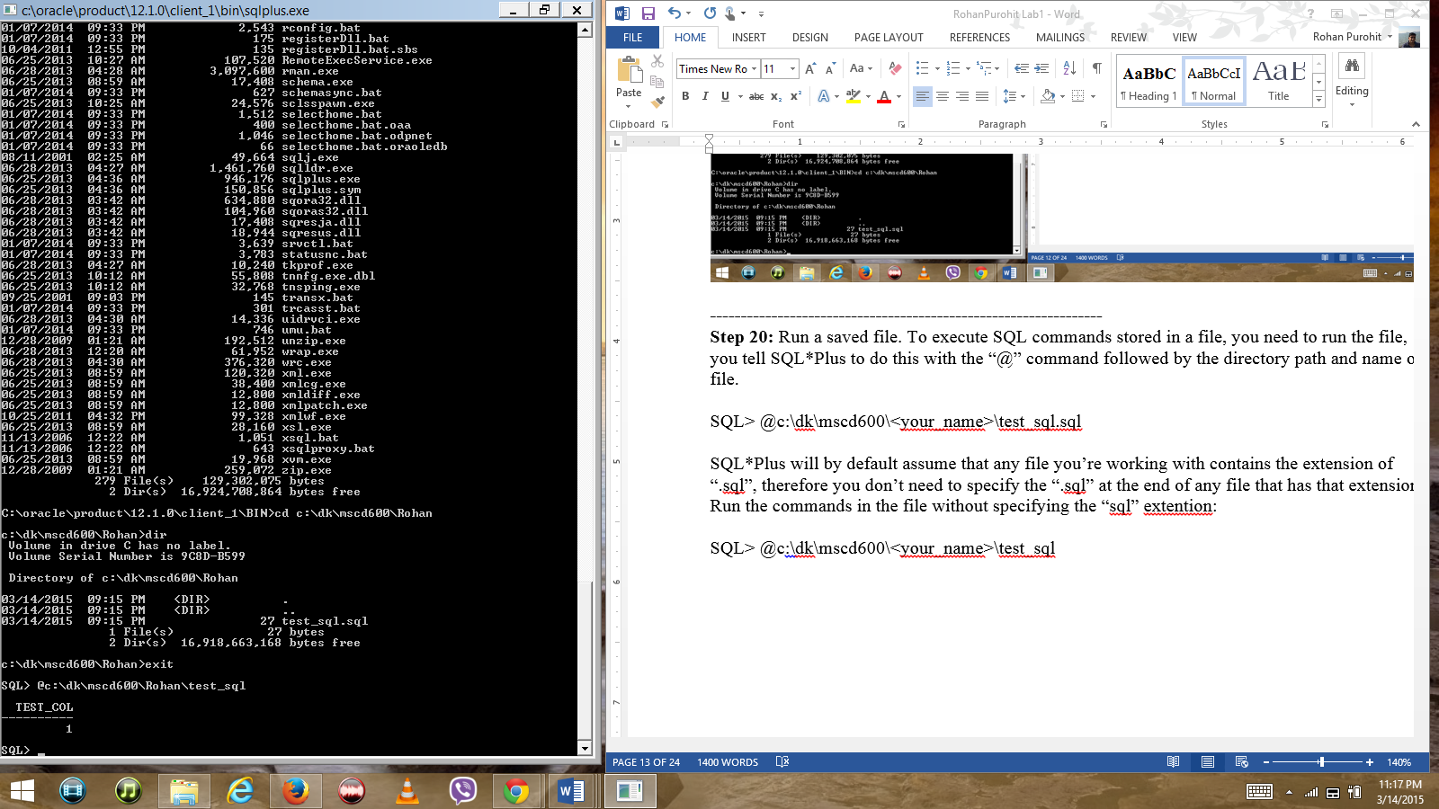

**----------------------------------------------------------------**

**Step 21:** Edit a file and place in it SQL commands:

SQL> edit c:\dk\mscd600\<your_name>\othersql.sql

For example, I would run this:

SQL> edit c:\dk\mscd600\darl\other.sql

This should open up the Windows Notepad utility.

Now place some commands in the file:

show user;

create table test_tab_2(test_col number, test_col2 varchar2(30));

insert into test_tab_2 (test_col, test_col2) values (5,'Hello world');

commit;

Save the file and exit Notepad.

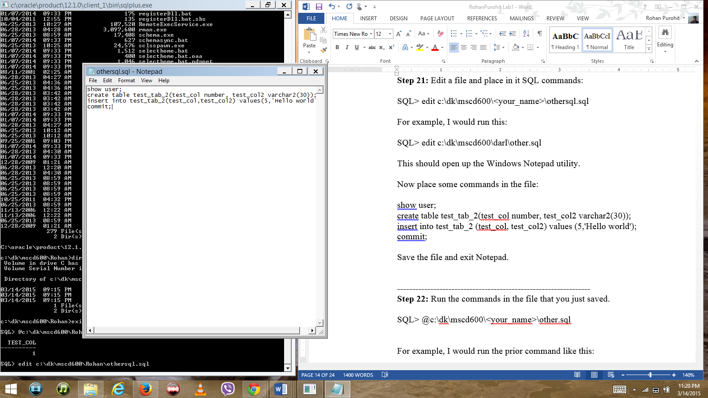

**----------------------------------------------------------------**

**Step 22:** Run the commands in the file that you just saved.

SQL> @c:\dk\mscd600\<your_name>\other.sql

For example, I would run the prior command like this:

SQL> @c:\dk\mscd600\darl\other.sql

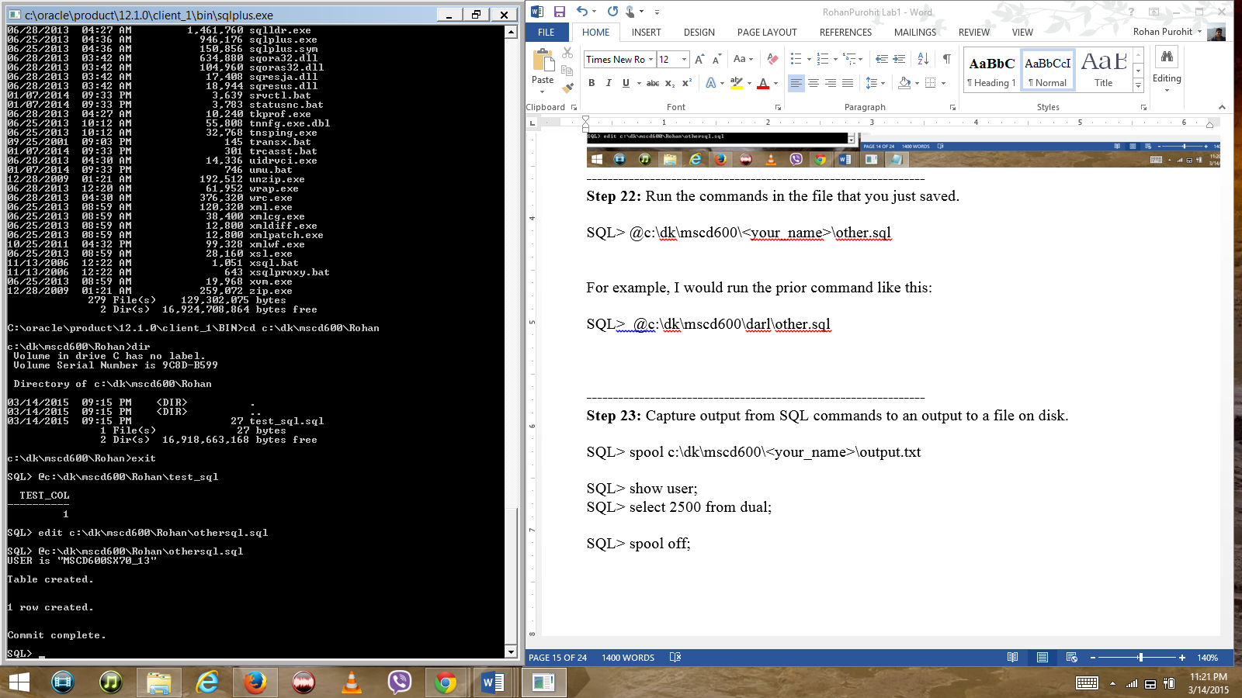

**----------------------------------------------------------------**

**Step 23:** Capture output from SQL commands to an output to a file on disk.

SQL> spool c:\dk\mscd600\<your_name>\output.txt

SQL> show user;

SQL> select 2500 from dual;

SQL> spool off;

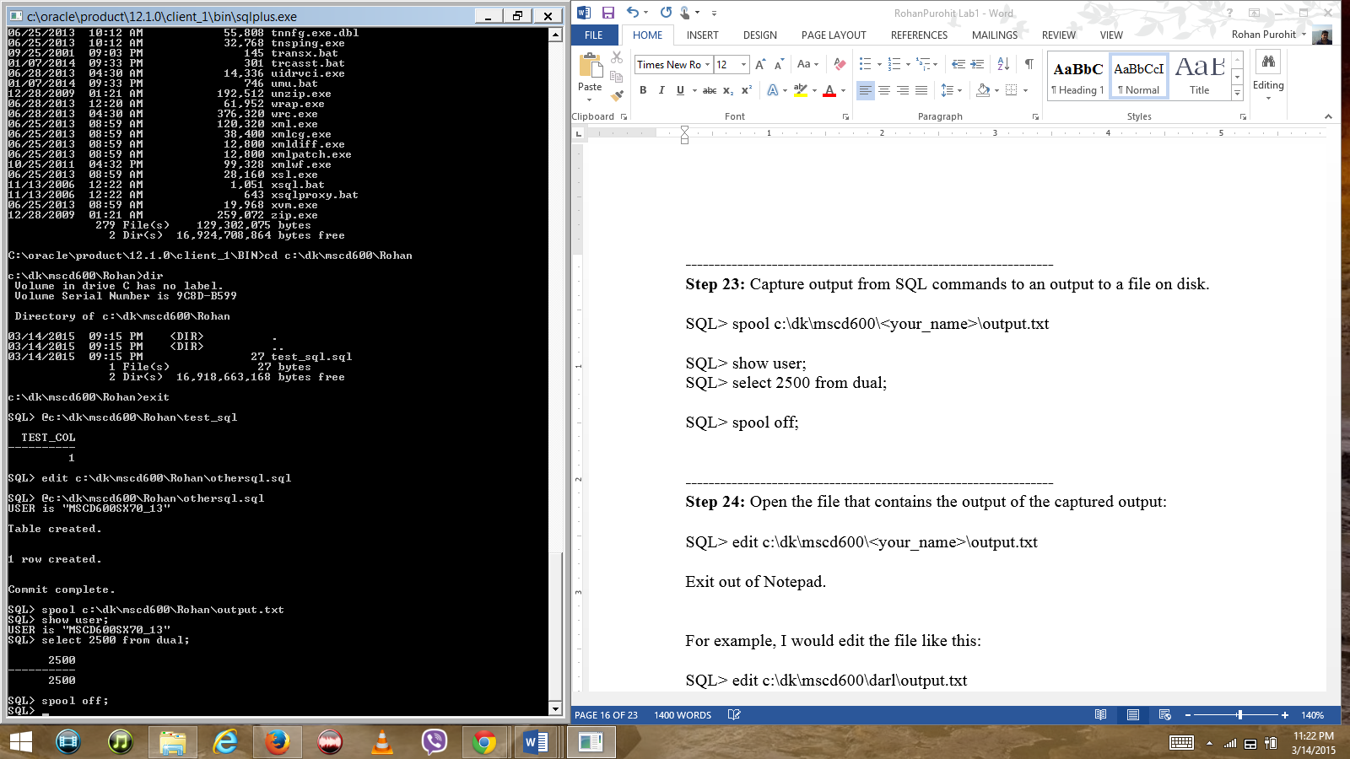

**----------------------------------------------------------------**

**Step 24:** Open the file that contains the output of the captured output:

SQL> edit c:\dk\mscd600\<your_name>\output.txt

Exit out of Notepad.

For example, I would edit the file like this:

SQL> edit c:\dk\mscd600\darl\output.txt

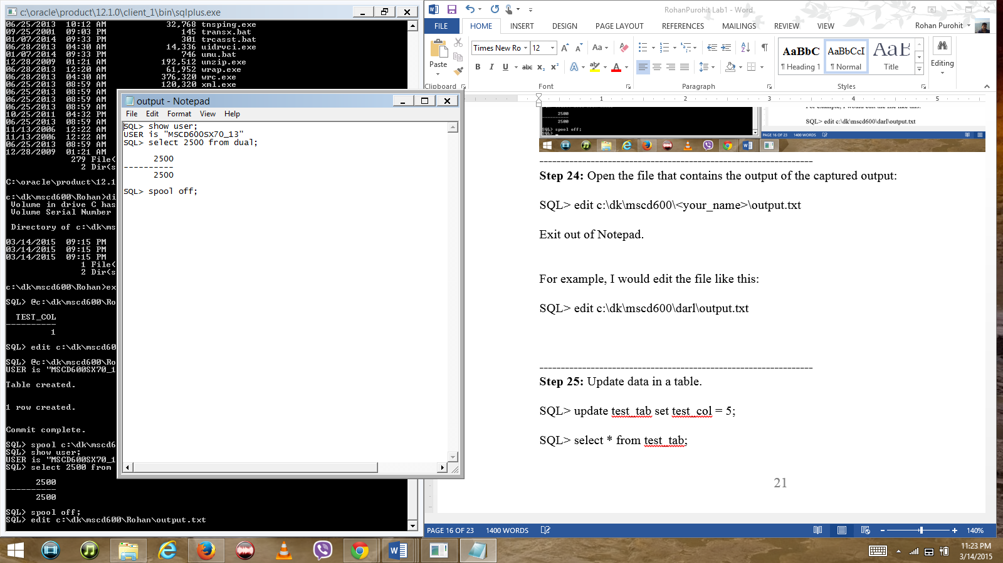

**----------------------------------------------------------------**

**Step 25:** Update data in a table.

SQL> update test_tab set test_col = 5;

SQL> select * from test_tab;

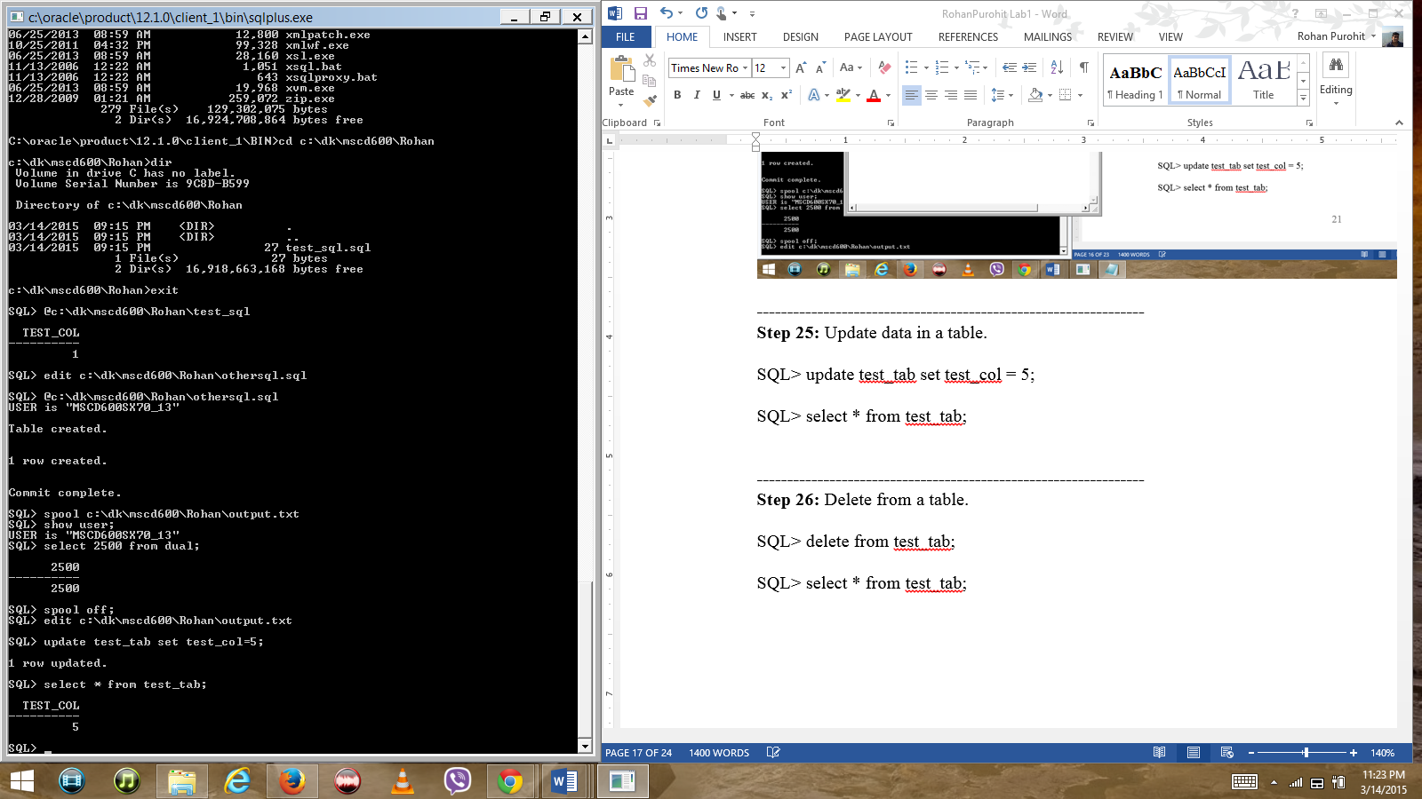

**----------------------------------------------------------------**

**Step 26:** Delete from a table.

SQL> delete from test_tab;

SQL> select * from test_tab;

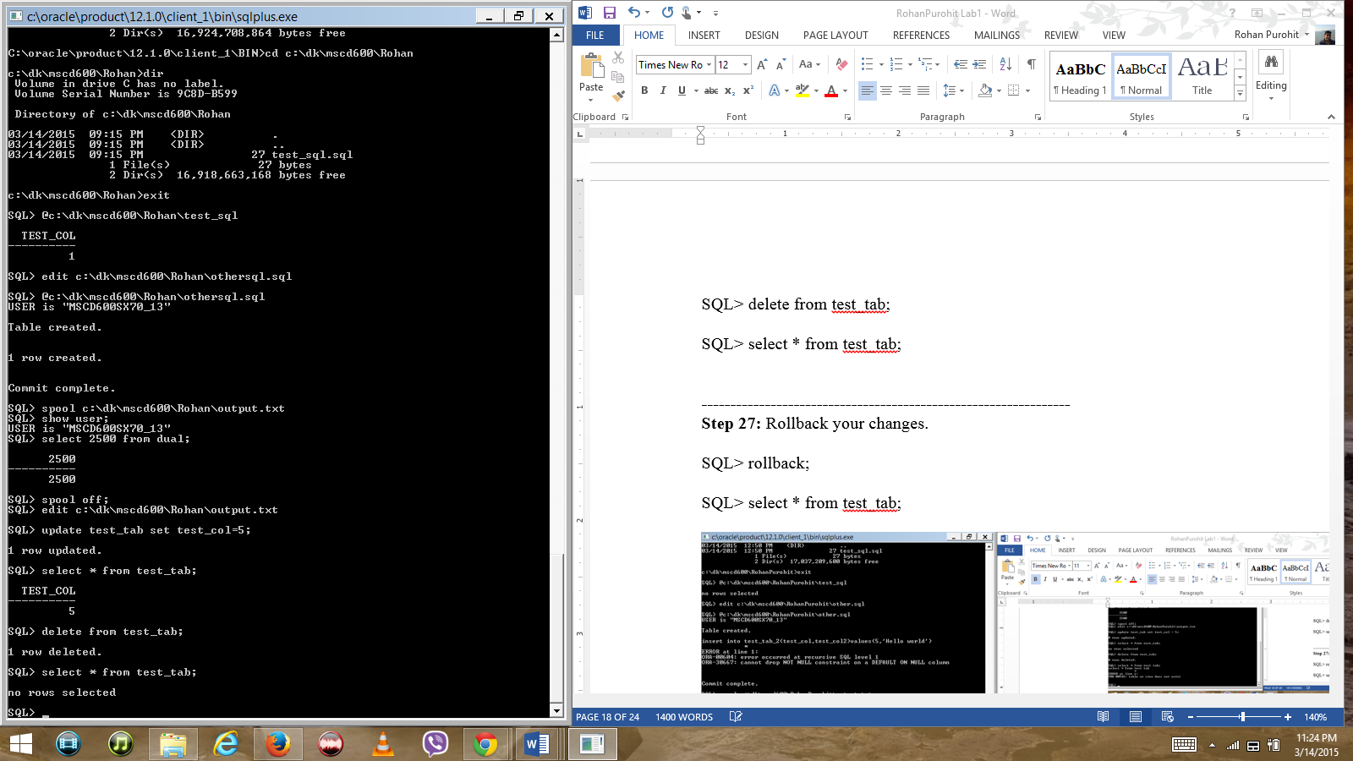

**----------------------------------------------------------------**

**Step 27:** Rollback your changes.

SQL> rollback;

SQL> select * from test_tab;

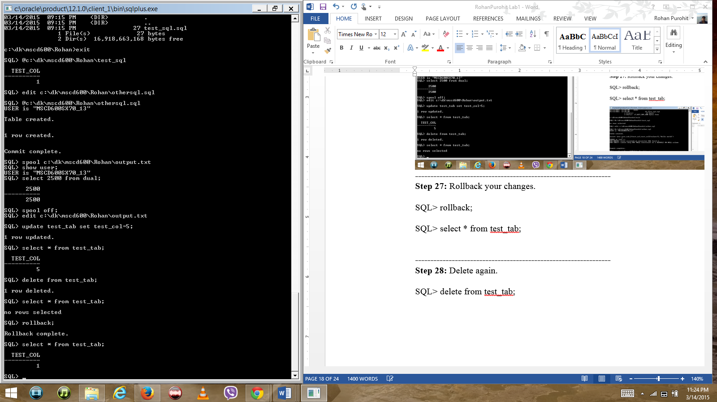

**----------------------------------------------------------------**

**Step 28:** Delete again.

SQL> delete from test_tab;

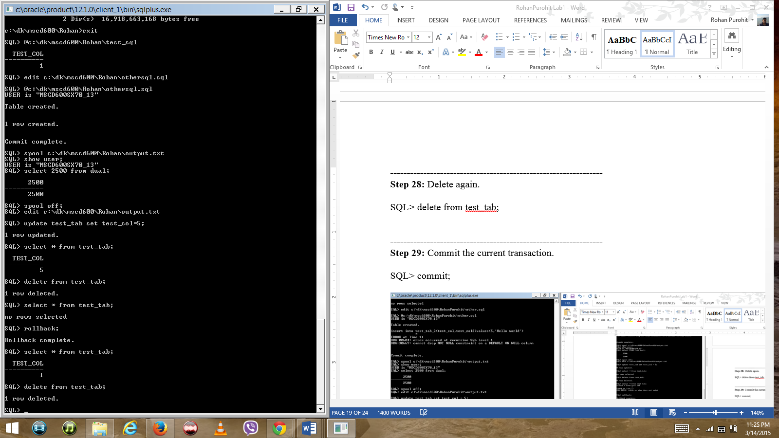

**----------------------------------------------------------------**

**Step 29:** Commit the current transaction.

SQL> commit;

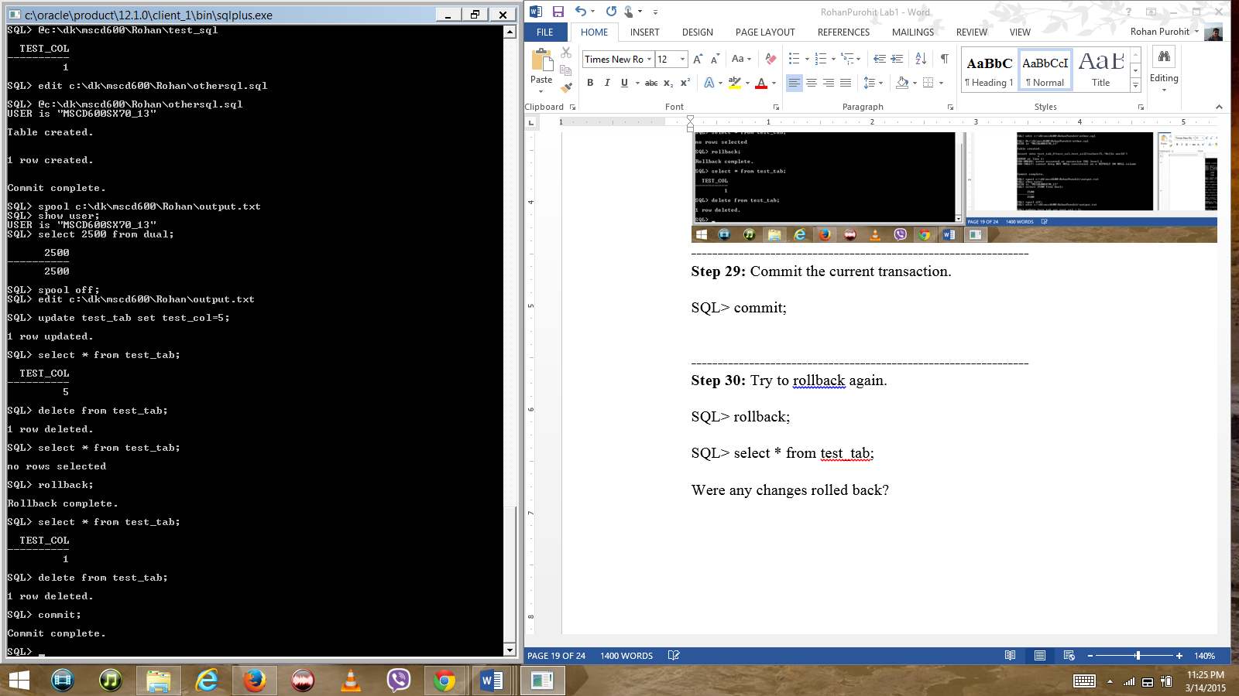

**----------------------------------------------------------------**

**Step 30:** Try to rollback again.

SQL> rollback;

SQL> select * from test_tab;

Were any changes rolled back? All rows were deleted.

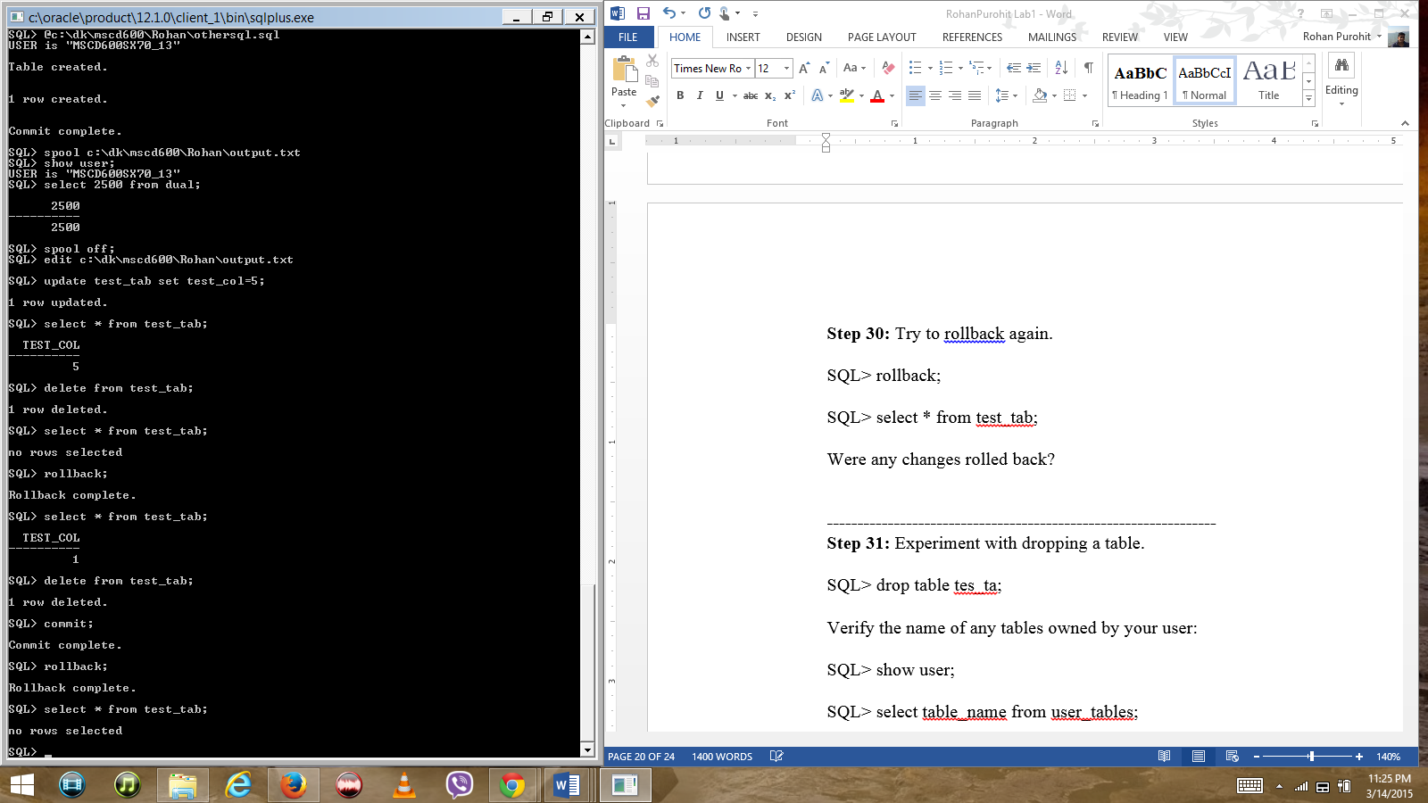

**----------------------------------------------------------------**

**Step 31:** Experiment with dropping a table.

SQL> drop table tes_ta;

Verify the name of any tables owned by your user:

SQL> show user;

SQL> select table_name from user_tables;

Now drop the table with the correct name:

SQL> drop table test_tab;

Drop this table also:

SQL> drop table test_tab_2;

Verify:

SQL> desc test_tab;

SQL> desc test_tab_2;

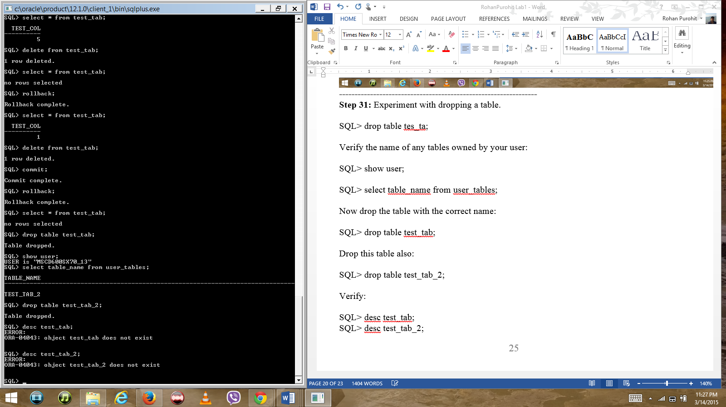

**----------------------------------------------------------------**

**Step 32:** How many users are currently connected to the database?

SQL> select distinct username from v$session;

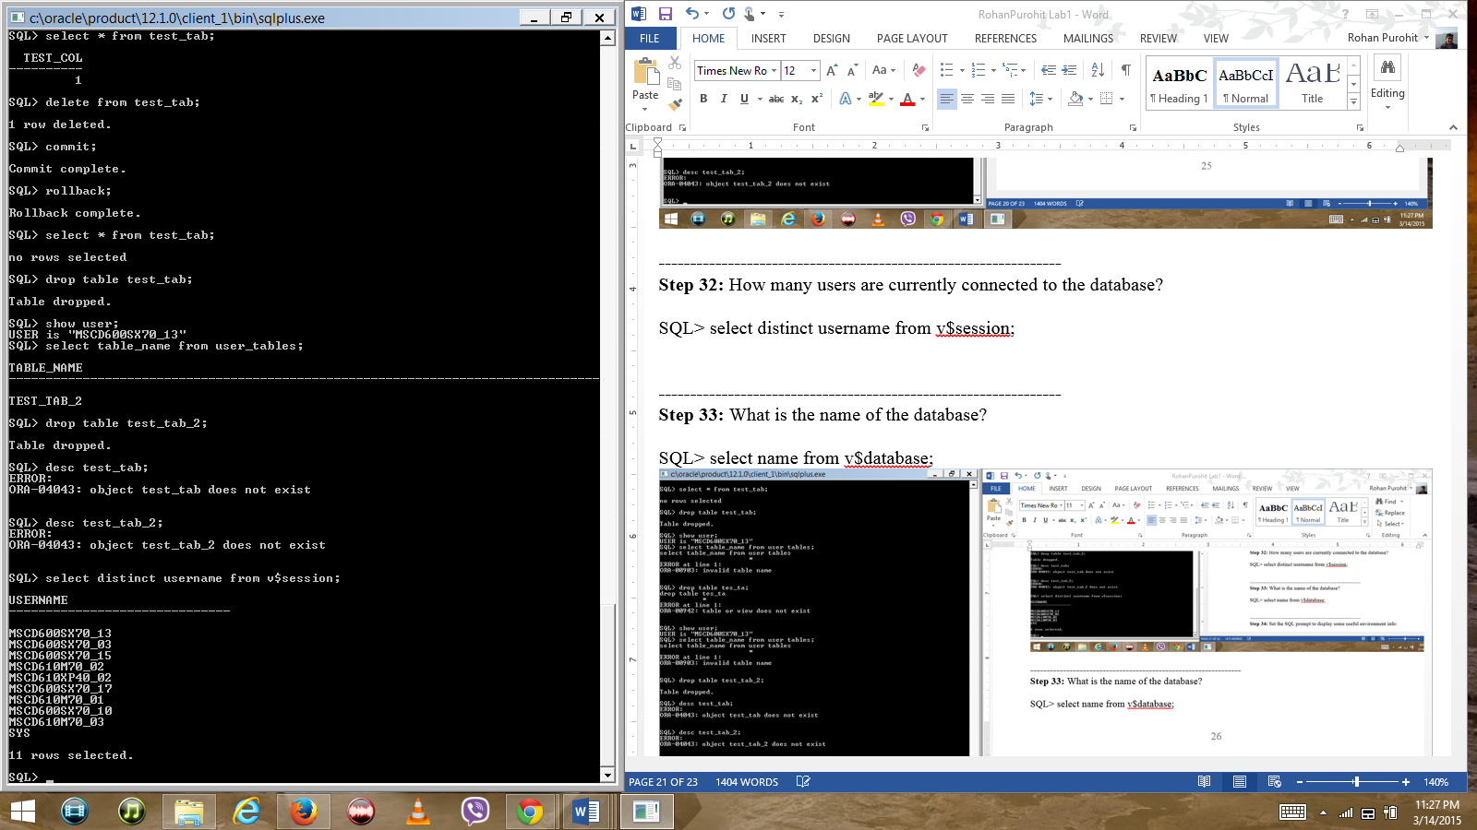

**----------------------------------------------------------------**

**Step 33:** What is the name of the database?

SQL> select name from v$database;

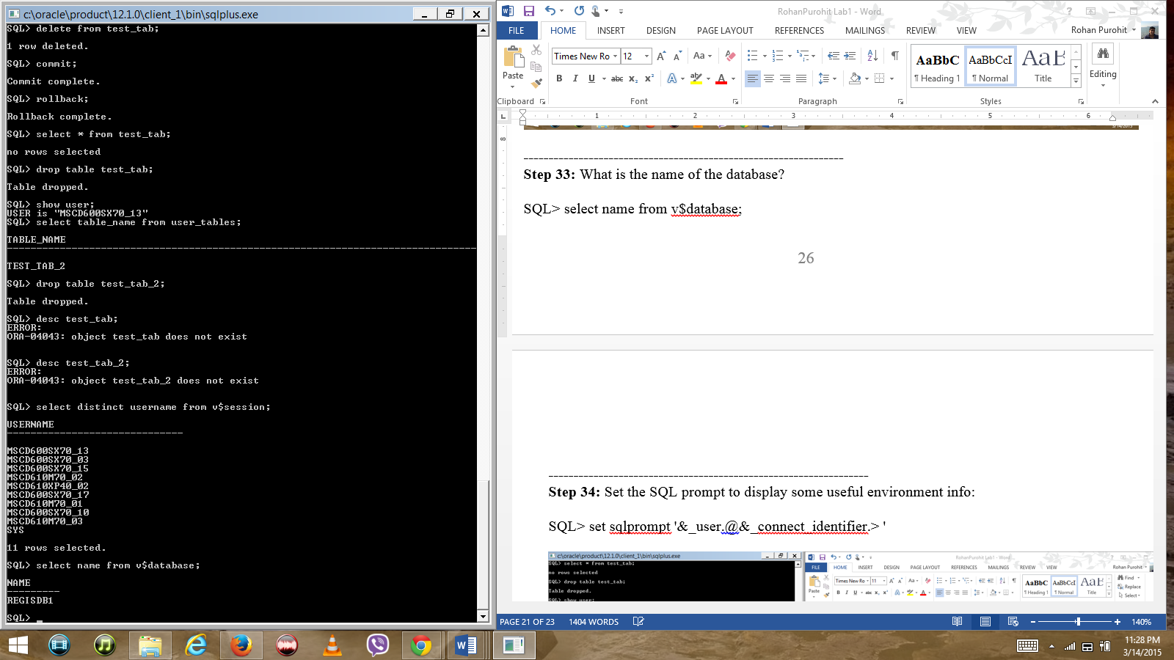

**----------------------------------------------------------------**

**Step 34:** Set the SQL prompt to display some useful environment info:

SQL> set sqlprompt '&_user.@&_connect_identifier.> '

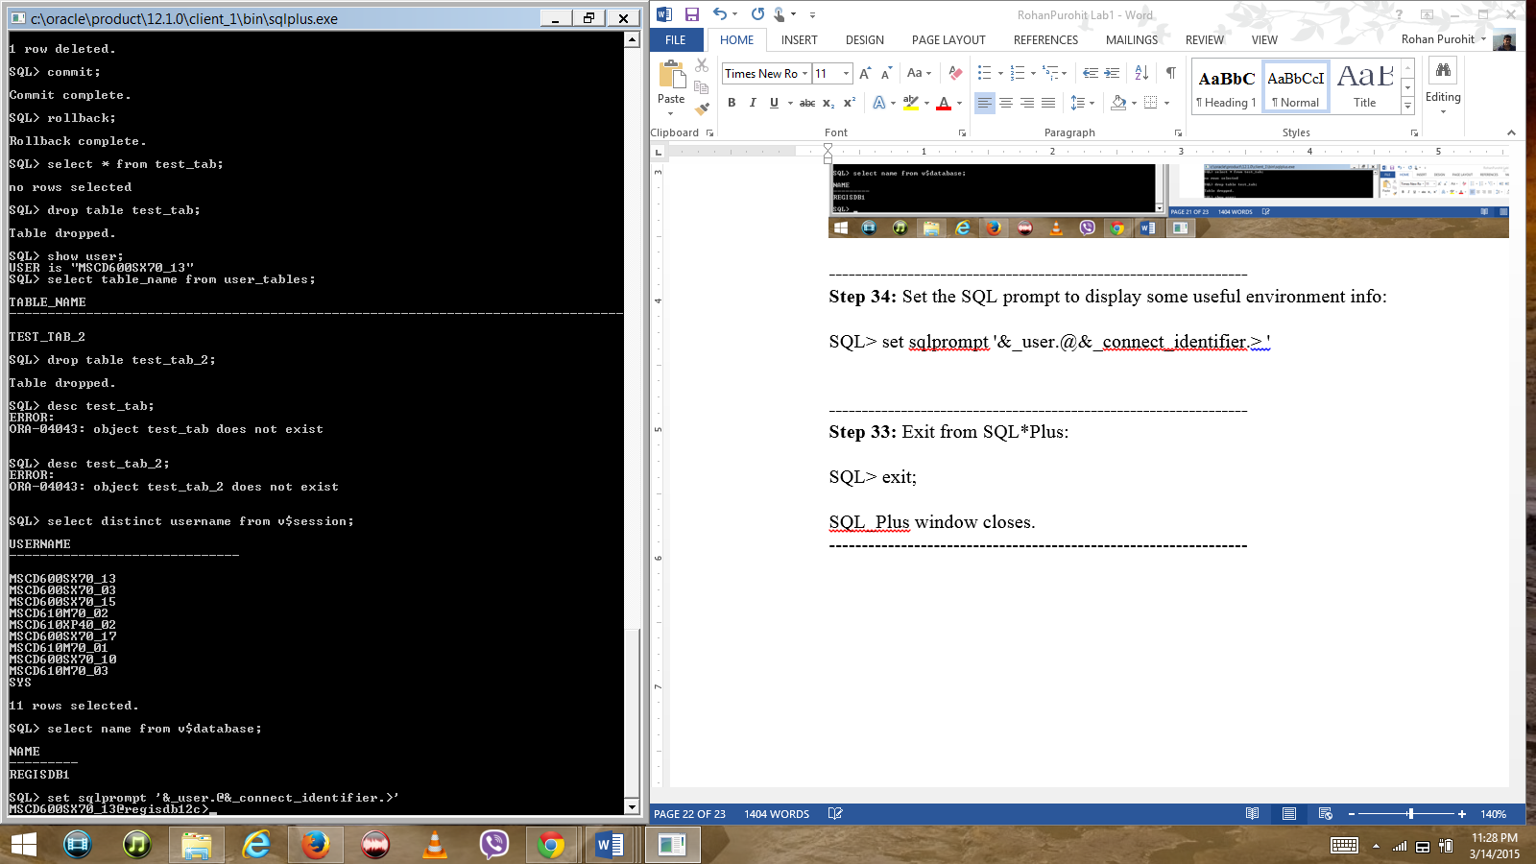

**----------------------------------------------------------------**

**Step 33:** Exit from SQL*Plus:

SQL> exit;

SQL_Plus window closes.

----------------------------------------------------------------

**MSCD 600 Database Architecture**

**Labs Rubric**

|  |  |
| --- | --- |
| **Grade** | **Rubric: Labs** |
| A  90-100% | -The lab work is technically sound  -The lab work addresses the criteria and exceeds the minimum requirements for the lab assignment.  -Met submission deadline.  - The deliverable format meets all requirements.  -Each item is clearly delineated and easy to follow.  -The submitted work is free from errors. |
| B  80-89% | -The lab work is technically sound  -The lab work addresses the criteria and meets the minimum requirements for the lab assignment.  -Met submission deadline.  - The deliverable format meets all requirements.  -Most items are clearly delineated and easy to follow.  -The submitted work has one to two errors. |
| C  70-79% | -The lab work is technically sound  -The lab work addresses the criteria and meets the minimum requirements for the lab assignment.  -Met submission deadline.  - The deliverable format meets most requirements.  -Most items are clearly delineated and easy to follow.  -The submitted work has more than two errors. |
| D  60-69% | -The lab work is not technically sound  -The lab work addresses the criteria and meets some of the minimum requirements for the lab assignment.  -Met submission deadline.  - The deliverable format meets some requirements.  -Few items are clearly delineated and easy to follow.  -The submitted work has more than three errors. |
| F  Less than 60% | -The lab work is not technically sound  -The lab work does not meet the base criteria nor the minimum requirements for the lab assignment.  -Did not meet submission deadline.  -The deliverable format meets some requirements.  -Few items are clearly delineated and easy to follow.  -The submitted work has more than four errors. |